DATEROEM WOOD SALES
System Documentation
AI Assistant
Chat assistant, insights, handwriting scan and description tidy-up
Document | AI Assistant
Document number | DWS-BE-04
Version | 1.1
Date | 25 October 2026
Intended readers | The business owner and developers
Classification | Internal - contains system design details; share only with authorised staff
Describes every AI feature in the system, what data the AI may see, how answers are kept safe and role-appropriate, which providers are used and what they cost, and where to change prompts, models and behaviour.

Document control
Version | Date | Change
1.0 | 3 October 2026 | First complete edition, written from the source code as it stood on this date.
1.1 | 4 October 2026 | Website answers link to the Featured page; promotions are quoted only while running and with products, the same rule as the website.
1.1 | 23 October 2026 | The assistant names a customer's orders by their ticket (DW-7K3Q9P) and offers Track my order (/track) to visitors who are not signed in.
1.1 | 25 October 2026 | Description tidy-up: the website never shows the tidied copy of an old description.
1.1 | 25 October 2026 | The website assistant knows the company facts (what we sell, Central Kenya sourcing, the Nakuru workshop, @dateroem.woods) and asks once more when an answer stops after promising details.
Keep this document up to date: when a feature, setting or server changes, edit the matching section here and add a line to the table above.
Contents
1 Introduction 3
2 Chat assistant 4
2.1 Two channels 4
2.2 What the assistant is told 4
2.3 Safety rules built in 5
2.4 Website helpful-moment nudges 5
2.5 Where to change what the assistant says 6
3 Insights 7
4 Handwriting scan 8
5 Description tidy-up 9
6 Providers, models and cost 10
7 Development history 11

1 Introduction
The system uses AI in four places. In every case the AI provider never touches the database: the backend decides exactly which facts to send, and checks what comes back before anyone sees it.
Feature | Who uses it | Provider | Backend code
Chat assistant | Website visitors (with or without an account); staff in the mobile app | Groq by default; Anthropic optional | AiChatService, GroqClient, AnthropicClient
Insights | Admins (mobile AI Insights, desktop Insights) | None - database queries | TransactionService, FarmerService, ExpenseService
Handwriting scan | Staff recording bulk production sheets | Anthropic (Claude, vision) | AnthropicClient.scan, DeliveryController
Description tidy-up | Website product pages | Same provider as chat | DescriptionFormatter
Table 1: AI features

2 Chat assistant
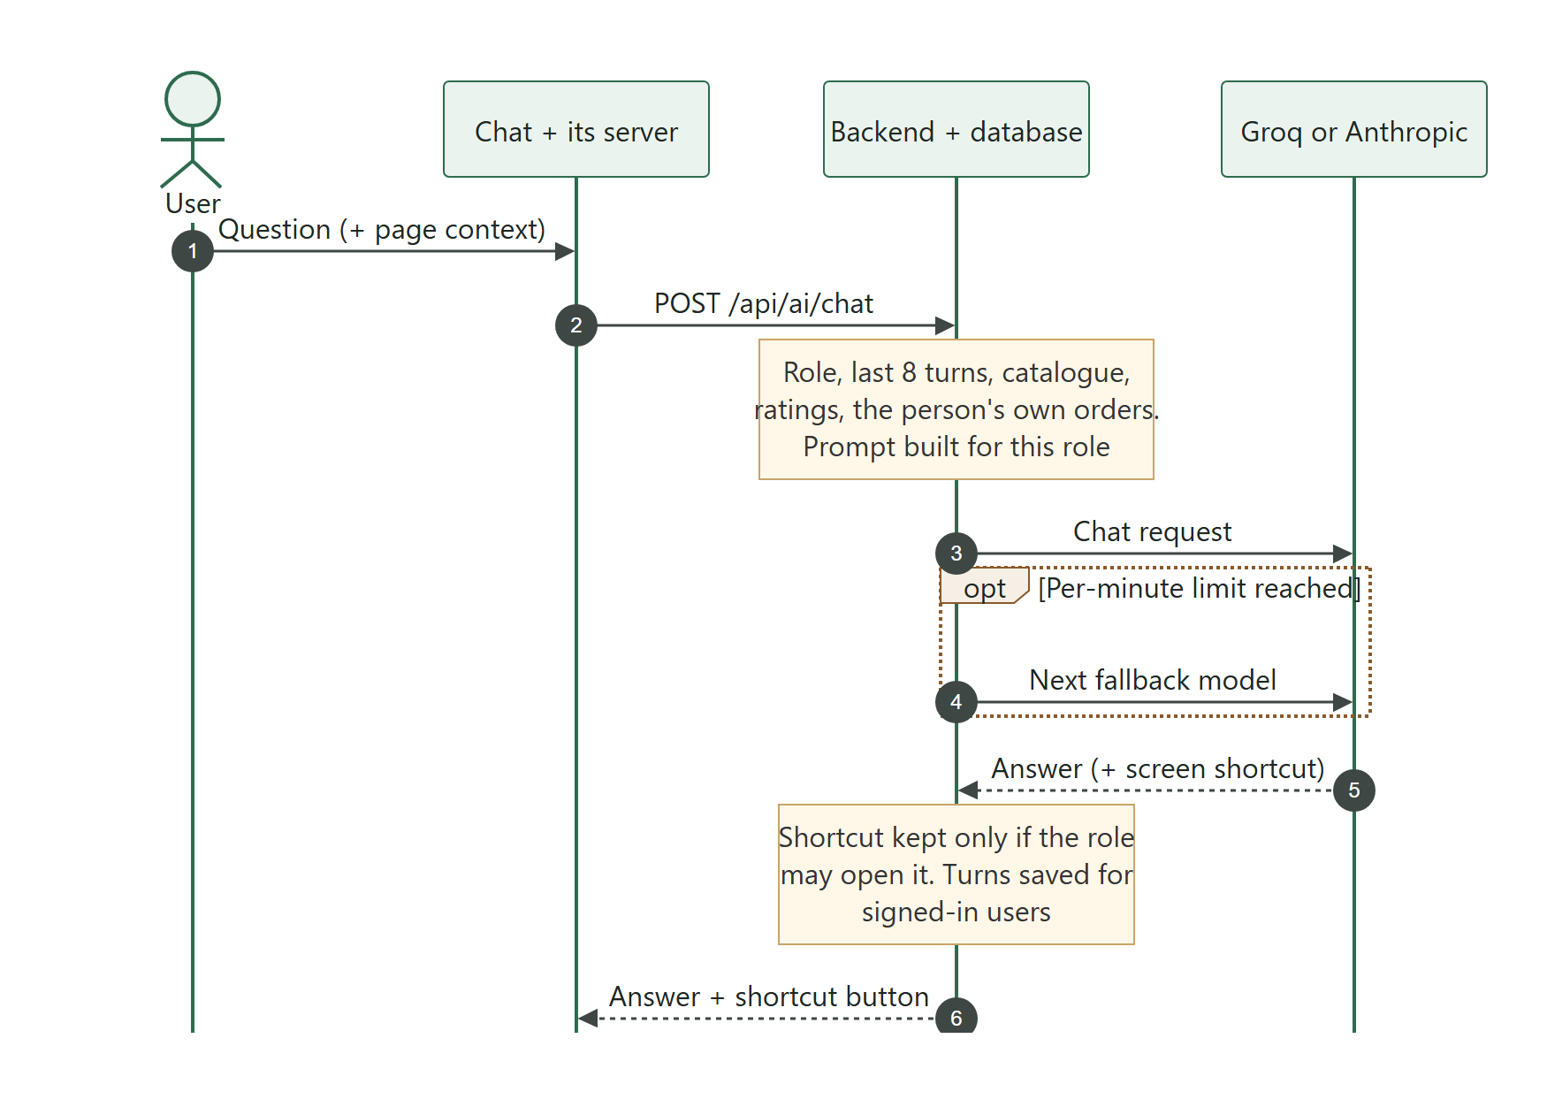
Figure 1: How a chat question is answered

2.1 Two channels
- Website (channel "web") - a floating chat panel on every page. It works without an account. For a signed-in customer it can also talk about their own orders. Visitors without an account get answers too, but nothing is saved; the website sends its own copy of their last turns.
- Mobile app (channel "mobile") - a floating button in the bottom dock opens a compact chat card. It guides staff through the app for their own role and can show a button that opens the right screen. Conversations are saved and can be browsed by date (the clock icon).

2.2 What the assistant is told
Information | Website | Mobile app
Company facts: what we sell, where the timber comes from, the workshop (Ebenezar Plot, Old Nairobi Road, Nakuru), @dateroem.woods | Yes (COMPANY_FACTS, since 25 October 2026) | -
Business facts and buying rules | Yes (WEB_BUYING_FACTS) | Yes (SYSTEM_PROMPT_HEADER)
Product catalogue (up to 60 products, prices, stock, categories) | Yes | -
Ratings summaries | Yes | -
Promotions running now (Active, within their dates, with products) and pickup points | Yes | -
Contact details | Yes (from the website server settings) | -
The person's own orders (up to 10, named by their ticket, like DW-7K3Q9P) | Signed-in customers only | -
Page the question came from (product, cart, empty search) | Yes, looked up again in the database | -
How-to guide for each part of the app | - | Only the parts this role can use
Live counts ("right now") | - | Orders waiting (managers up); unassigned payments and refunds (admins)
Screens the user may open | Website pages | Role-filtered app screens
Last 8 turns of the conversation | Yes | Yes
Table 2: Context given to the model

2.3 Safety rules built in
- The model never queries the database. Only the facts in the table above are sent.
- Suggested screens are checked against the list that role may open; a wrong or invented screen is dropped.
- Customers never see internal order ids; they see their own order numbers.
- Product facts named by the browser (product id, cart lines, search text) are looked up again on the server; nothing the browser claims is trusted.
- Language: the backend detects Kiswahili from common words and tells the model to reply in the same language.
- Answers that look cut off are requested once more.
- An answer that ends on a colon - it promised steps or details and stopped - is asked for once more (GroqClient, since 25 October 2026: the model returned only "Sure, here's how to pay with M-Pesa:" about one time in three); if the second try is no better, the first answer stands.
- When the provider is at its per-minute limit, the next fallback model is tried. If all are busy, the user is asked to try again in a few seconds and the website stops inviting questions until the limit passes (/api/ai/chat/status).
- If the backend cannot be reached at all, the website retries once and then falls back to the keyword helper in the website server (frontend/app/routers/help.py).

2.4 Website helpful-moment nudges
The website's chat button stays still until a visitor looks unsure, then sends out one growth ring and, once per visit, a short label. Triggers: about 40 seconds on one product without adding it to the cart, returning to a product seen earlier in the visit, lingering in the cart for about 30 seconds, or a search that finds nothing. At most two nudges and one label per visit, nothing in the first 15 seconds, two minutes between nudges, never while scrolling or typing, never during payment, none after the chat has been opened, no label until cookies are answered, and only when the assistant is available. Opening the chat from a nudge pre-fills one-tap questions for that page.
Where to adjust: All nudge timings are in NUDGE_TIMING in frontend/website/src/context/ChatNudgeContext.jsx; the one-tap questions are QUICK_QUESTIONS in frontend/website/src/components/HelpWidget.jsx.

2.5 Where to change what the assistant says
To change | Where (backend/.../service/AiChatService.java unless stated)
Website tone, rules and buying facts | WEB_SYSTEM_PROMPT_HEADER, WEB_BUYING_FACTS
Company facts (who we are, where we are) | COMPANY_FACTS - keep it in step with the About page (core/aboutStory.js)
Staff assistant rules | SYSTEM_PROMPT_HEADER
How-to guides per app section | MOBILE_GUIDES (each tagged with the roles that may use it)
Screens a reply may link to | NAV_ENTRIES (mobile) and WEB_NAV_ENTRIES (website, which links campaigns to the Featured page, /featured); keep in step with the app's routes in HomeShell.kt and the website routes in App.jsx
When a promotion may be mentioned | buildPromotionContext: Active, today within its dates and at least one product not in the bin - the same rule the website server uses for the Featured page (_is_live in frontend/app/routers/marketing.py). With none running, the model is told never to offer a deal.
Role descriptions | ROLE_SUMMARIES
Product categories used in answers | KINDS, BULK, DECOR (matched on product name, then note, then type)
How much history and catalogue is sent | HISTORY_TURNS (8), CATALOG_LIMIT (60), ACCOUNT_ORDER_LIMIT (10), GUEST_TURN_CHARS (700)
Kiswahili detection words | KISWAHILI_WORDS
Contact details quoted | support_email, support_phone, support_whatsapp in frontend/app/core/config.py

Chat history is stored in AI_CHAT_MESSAGES (user, role user/assistant, content, suggested route and label, time).

3 Insights
The insights screens are plain database reports presented as an "AI" section for admins: unassigned transactions (tap one to assign it), top farmers by trees supplied across trips, the expense breakdown per trip and category (highest first) and, on the desktop, the pending orders grouped per customer. No external AI provider is involved.

4 Handwriting scan
Bulk deliveries carry production description lines (product type, measurements such as 6x6x4, total body feet and product total). Staff can photograph a handwritten sheet; POST /api/deliveries/bulk/{id}/production/scan sends the image to Anthropic's vision model (app.anthropic.model) and returns the values to fill the form. The person reviews and saves them. A photo can also simply be attached to a line without scanning.
Note: The scan always uses Anthropic, whatever the chat provider is set to. It needs ANTHROPIC_API_KEY and an Anthropic account with credit; without them the scan returns a clear "not available" message and nothing else is affected.

5 Description tidy-up
Sellers can paste long, untidy product descriptions. After a product is saved, DescriptionFormatter asks the chat provider for a cleaner layout in the background. The result is kept only if every number and fact still matches the original; otherwise the website's own built-in tidy-up is used. The seller's text is never changed. A sweep every 5 minutes fills in anything missed. Switch it off with DESCRIPTION_AI_TIDY_UP=false. Until the new copy is ready - right after an edit, or while the AI cannot be reached - the website shows the new description in its own layout, never the tidied copy of the old one (since 25 October 2026).

6 Providers, models and cost
Environment variable | Property | Value today | Purpose
AI_CHAT_PROVIDER | app.ai.chat-provider | groq | Which AI answers chat: groq or anthropic.
GROQ_API_KEY | app.groq.api-key | none (secret) | Groq API key (console.groq.com).
GROQ_CHAT_MODEL | app.groq.chat-model | openai/gpt-oss-120b | Main Groq chat model.
GROQ_FALLBACK_CHAT_MODELS | app.groq.fallback-chat-models | openai/gpt-oss-20b, qwen/qwen3.8-27b | Tried in order when the main model is at its per-minute limit.
ANTHROPIC_API_KEY | app.anthropic.api-key | none (secret) | Anthropic (Claude) API key - handwriting scan, optional chat.
ANTHROPIC_MODEL | app.anthropic.model | claude-haiku-4-5-20251001 | Model used for the handwriting scan.
ANTHROPIC_CHAT_MODEL | app.anthropic.chat-model | claude-sonnet-5 | Model used for chat when the provider is anthropic.
DESCRIPTION_AI_TIDY_UP | app.descriptions.ai-tidy-up | true | Let the AI arrange long product descriptions for the website.
Table 3: AI settings
- Groq (default for chat) has a free tier that needs no card. Each model has its own allowance of about 8,000 tokens per minute, which is why fallback models are listed. Get a key at console.groq.com.
- Anthropic (Claude) is paid per use. It is required for the handwriting scan and can also run the chat.
- To move chat to Anthropic: fund the Anthropic account, set ANTHROPIC_API_KEY, set AI_CHAT_PROVIDER=anthropic, then restart the backend. To change models, set the model variables above.

Where to adjust: API keys are exported by the backend launch scripts: /root/run_backend.sh, /root/start_backend.sh, C:\Scripts\Launch-Dateroem.bat and the backend command in admin_server_control/desktop/app/core/server_manager.py.
Security: backend/keys_paths.tex contains an API key in plain text inside the project folder. Move it out of the project (or delete it), and replace (rotate) that key in the provider's console, because the file may have been copied or shared.

7 Development history
Date | Change
2026-09-13 | Forest theme and layout, marketer badges on products, AI help area (first as a keyword bot), over-ordering blocked by stock checks.
2026-09-15 | AI insights (unassigned transactions, top farmers, expense breakdown), handwriting scan of bulk production sheets, chat assistant in the mobile app with saved history, assistant on the website (Groq).
2026-09-16 | Voice assistant for filling forms (continuous, Android speech), machine and vehicle pickers, product images in the app.
2026-09-17 | Public access through ngrok, phone-friendly layout, Google Analytics behind cookie consent, side-panel help chat, cart icon, M-Pesa STK push at checkout (sandbox).
2026-09-19 | Orders section, floating chat button, side quests and reassignment of undelivered orders.
2026-09-20 | Role-based navigation guidance and chat history browsing; website answers improved.
2026-09-25 | Answers grouped into consistent categories; replies in Kiswahili when asked in Kiswahili.
2026-09-26 | Product ratings and reviews with a public-review agreement, long descriptions with an AI-arranged layout, delivered goods ordering, splash removed, gentle forest motion, emojis replaced by icons.
2026-10-02 | AI chat nudges at helpful moments, with the page context passed to the assistant.
2026-10-03 | Website answers point to the Featured page and mention a promotion only while it is running and has products.
2026-10-07 | Help page: frequently asked questions with a search box and topic buttons, each answer able to link to the page it is about; the first 16 written from the facts the website's assistant is given. Admins keep them in the desktop app (FAQs).
2026-10-18 | Clean-up before going live: test orders, payments, deliveries, trips, loans and finance, farmers, machines, vehicles, chats and the SMS queue removed, disabled accounts deleted, and everything kept numbered from 1 - the SuperAdmin is user 1, the two admins 2 and 3, the one real customer 4; the real KES 5 order is order 1; products 1-7. Full backups and a record in db_backups.
2026-10-23 | Order tickets like DW-7K3Q9P ("ticket number for tracking", migration 038) on every order - website, staff light deliveries and bulk orders - shown to customers and used by staff and the assistant. Track my order on the website without signing in (the ticket and the last 3 digits of the phone; five wrong tries lock a ticket for half an hour). The driver and vehicle are hidden from customers unless staff switch on Share driver for that delivery, on the desktop or the phone ("vehicle visible only to staff").
2026-10-25 | The modern chat ("especially the color behind it make it look modern like we did with the rest of the site"): the site's forest behind the chat, an emblem header with Online, a welcome with suggestions, frosted bubbles, a rounded message bar; the assistant learnt the company facts (it used to decline "Where are you located?") and asks again when an answer stops after promising details.

